# VISVESVARAYA TECHNOLOGICAL UNIVERSITY

"Jnana Sangama", Belagavi - 590018

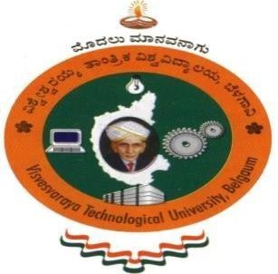

A Report on

#### Reduction in Energy Consumption

**NON CREDIT MANDATORY COURSE**

Submitted in partial fulfillment of the requirement for the award of the degree of

**Bachelor of Engineering in**

**Computer Science and Engineering**

**By**

**ANISH KUMAR**

**1AY21CS028**

Under the guidance of

**Mrs. VARALAKSHMI B D**

**Assistant Professor**

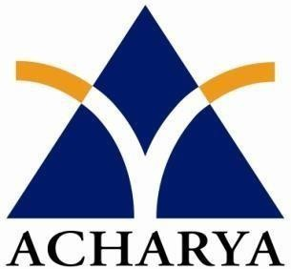**Department of Computer Science and Engineering**

**DEPARTMENT OF COMPUTER SCIENCE AND ENGINEERING**

**ACHARYA INSTITUTE OF TECHNOLOGY**

(Affiliated to Visvesvaraya Technological University, Belagavi)

2024-2025

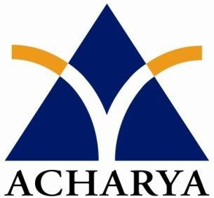 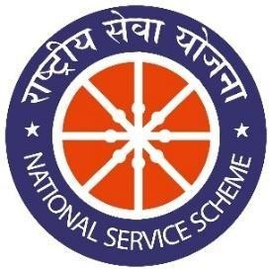



*OF PARTICIPATION*

This is to certify that Mr. Anish Kumar has successfully participated in the activity **Reduction in Energy Consumption** which was conducted on **From** - **10/04/2024 To - 18/04/2024** as a part of AICTE activity from the Department of CSE, AIT.

Signature of Department Coordinators

Prof. Varalakshmi B D